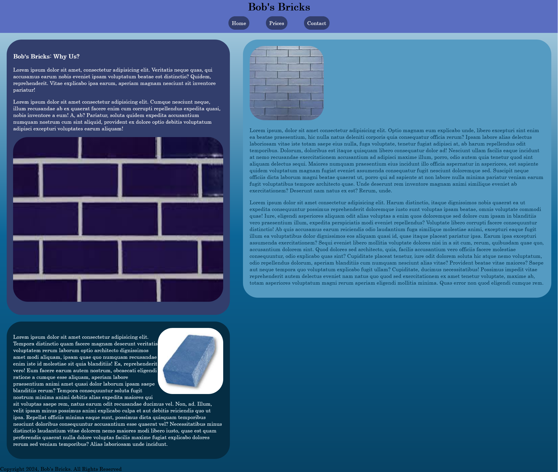

My First Website is “Bob’s Bricks”, a site about bob, who sells blue bricks. I used the color blue to represent stability, security and trustworthiness- all important aspects for creating long-lasting walls. The blues represent the stability of bricks. This website is monochromatic.

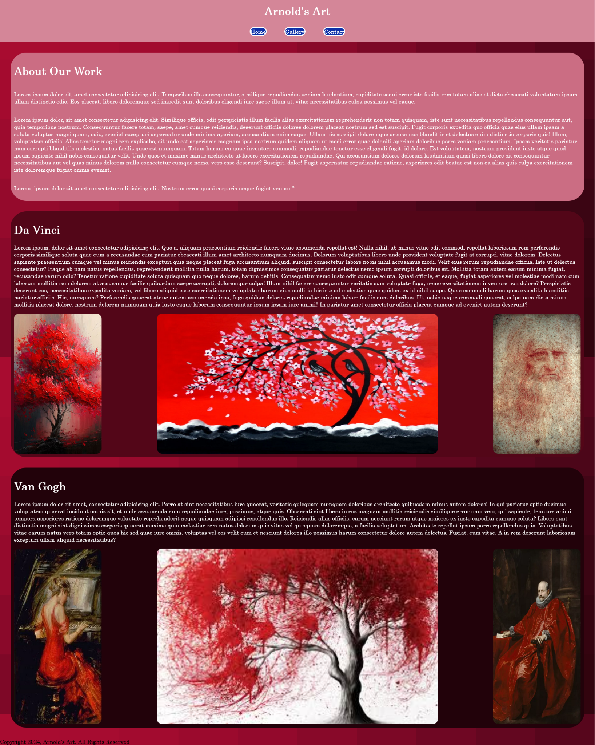

This website, which is a art gallery, is a example of analogous red color scheming. The red was chosen because of the topic- art. Art is a representation of the human emotional spectrum. It is a human being’s passion given form, representing nearly any idea, so long as the artist can represent it.

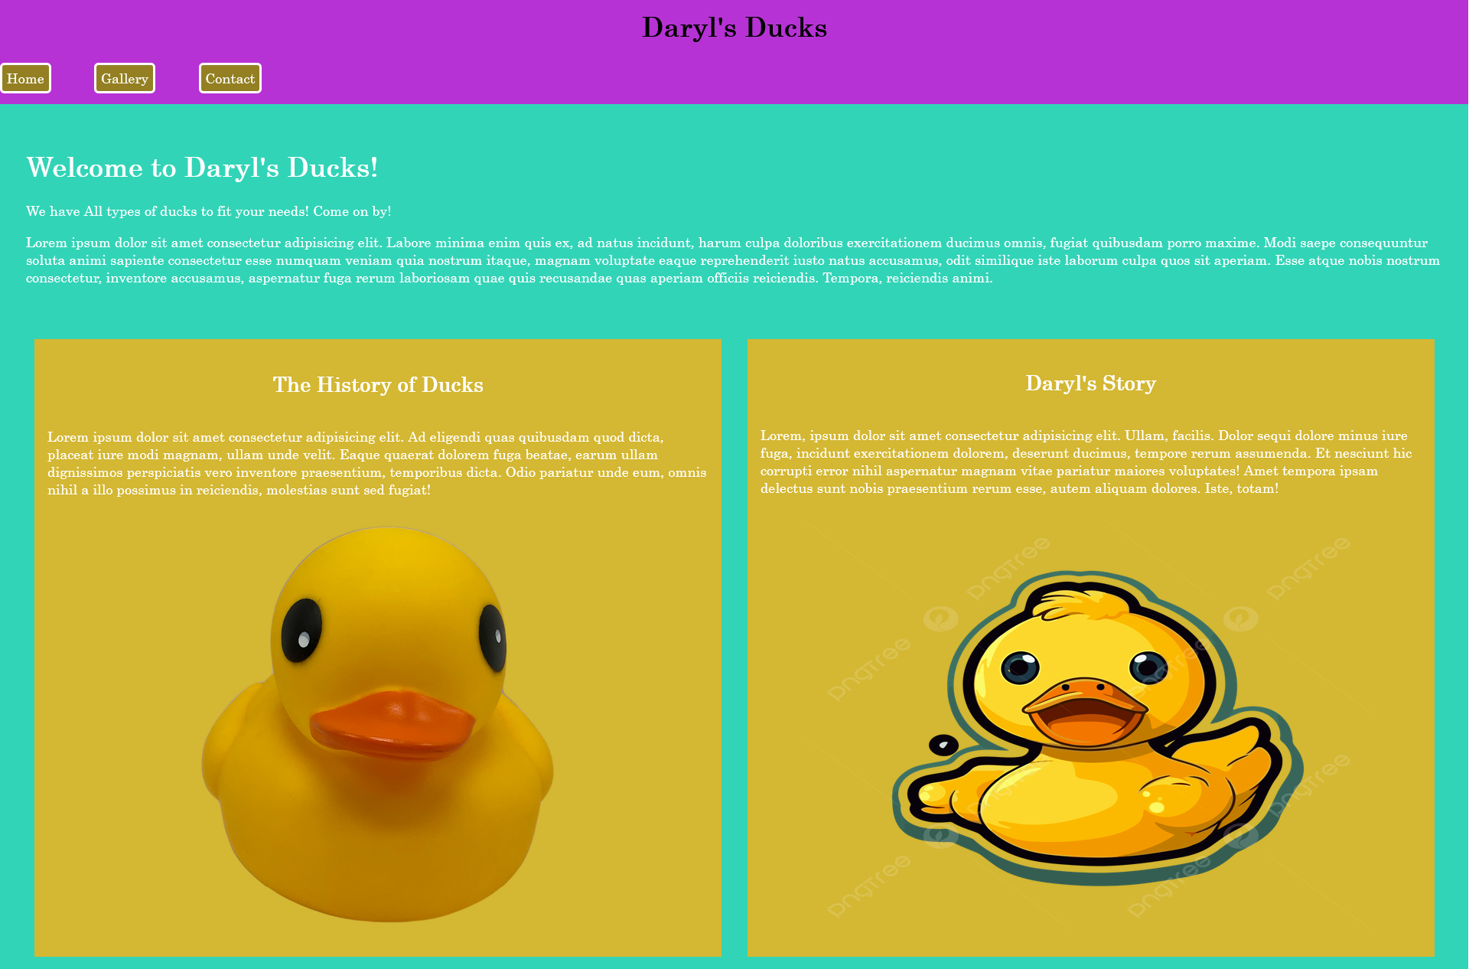

Daryl’s Ducks is a example of triadic color scheming. I used yellow to start with, as seen in the boxes. The yellow is attention getting, bringing attention to the content. It represents the childlike energy of playing with rubber ducks. The background, a light blue, represents tranquility, and refreshingness. A representation of the peacefulness of taking a bath. The purple represents the confidence and power behind the ducks- these rubber ducks are the best of all rubber ducks, the royalty of rubber ducks, even.